Product Design

**Team: 25**

| **Revision #** | **Revision Date** | **Summary of changes** | **Author(s)** |
| --- | --- | --- | --- |
| 0.1 | 10/06/2022 | Initial creation | Nick Triantos |
| 0.2 | 10/06/2022 | Design rationale for audio, battle system, and narrator | Kelsey Porter |
|  |  |  |  |

**Class Diagram:**

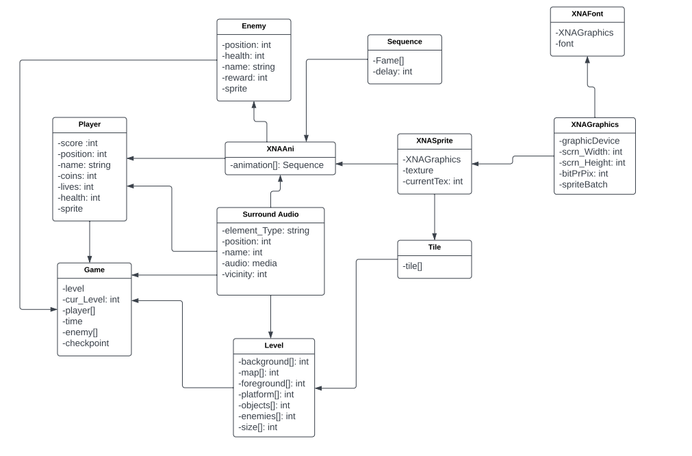

**Entity Relationship Diagram:**

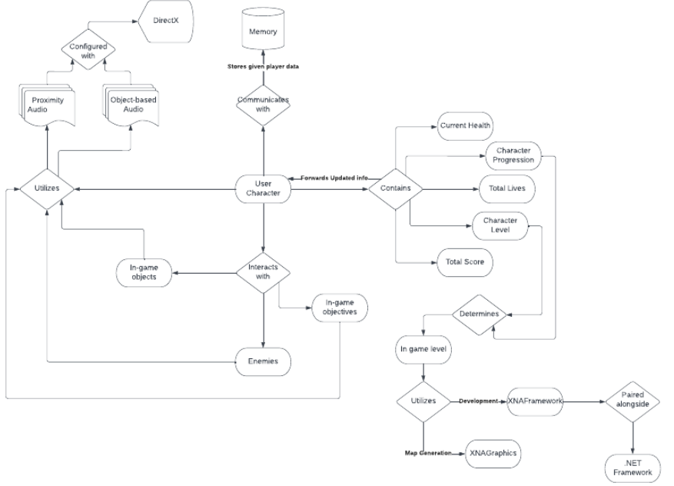

**UI Wireframes/Screenshots:**

* As the intended audience is blind, UI screenshots are not available at this time.

**Design Summary:**

Given that we have to design a game around a lack of one of the senses, we have opted to focus on the senses that can be used for a digital game, and as such, have put primary focus on spatial audio.

**Design Rationale:**

At first glance, the ideal method of navigation seems to be audio. The Monogame framework provides support for spatial audio so we’re using that to help orient the player. Further research also suggests text-to-speech audio navigation in the style of audio description used in film and TV.

When researching how to implement a simple real-time battle system, perhaps games such as Hades could be used as reference. Optionally, we could use an RPG turn-based system such as Final Fantasy.

We also had an idea for a narrator that would guide the player, such as in The Stanley Parable. Not sure though.